## **Name: Rohanur Rahman Ontu**

**Find me on**

LinkedIn: <https://www.linkedin.com/in/rohanur-rahman-ontu/>

Medium: <https://medium.com/@playwithdatawithontu>

Email: [rohanurrahmanontu@gmail.com](mailto:rohanurrahmanontu@gmail.com)

## **Project Title: CO₂ Emissions Analysis in Accommodation & Food Services (1995–2018)**

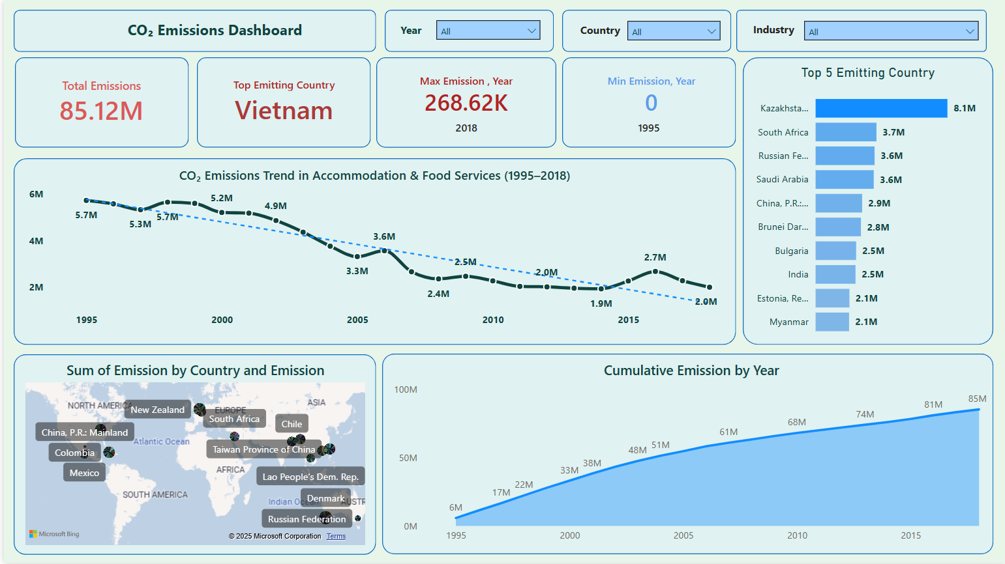

### **Introduction**

This interactive dashboard presents a comprehensive analysis of global CO₂ emissions specifically from the **Accommodation and Food Services** industry between **1995 and 2018**. The visualizations help track emission trends, identify major contributors, and understand how emissions have evolved over time and geography. The goal is to provide insights into carbon emissions within this industry and highlight opportunities for mitigation.

### **Key Insights & Narrative**

#### **🌍 Global Overview**

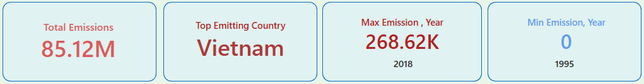

From 1995 to 2018, the Accommodation and Food Services sector contributed a **total of 85.12 million metric tons** of CO₂ emissions. This figure highlights the sector's significant environmental footprint over the years. **Vietnam** emerged as the **top emitting country**, while **Kazakhstan** recorded the **highest cumulative emissions** with **8.1 million metric tons**.

#### **📈 Trend Over Time**

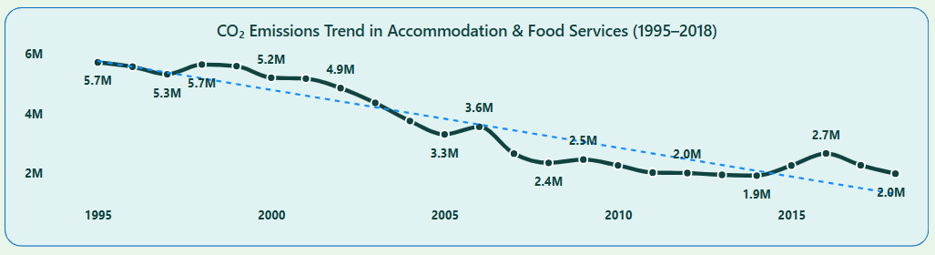

The **CO₂ Emissions Trend Line Chart** shows a **steady decline** in global emissions in this sector. Starting from **5.7M in 1995**, emissions dropped to **2.0M by 2018**. This trend indicates increasing global awareness and possibly improved energy efficiency, regulations, or changes in operational practices within the hospitality industry.

The **year 2018**, despite being at the end of the timeline, still recorded the **maximum single-year emission** of **268.62K metric tons**, hinting that some countries or regions continue to struggle with emission control.

#### **🥇 Top 5 Emitting Countries**

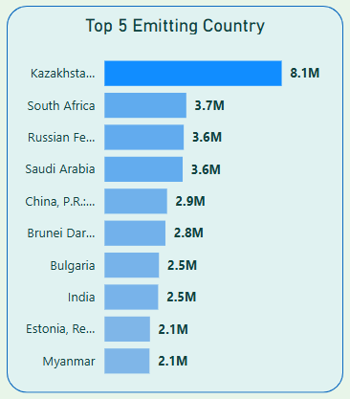

The **Clustered Bar Chart** ranks countries by total emissions. **Kazakhstan** leads with **8.1M**, followed by **South Africa, Russian Federation, Saudi Arabia**, and **China**. This insight is vital for targeted policy-making and international collaboration efforts to reduce emissions in high-impact regions.

#### **🗺️ Geographical Distribution**

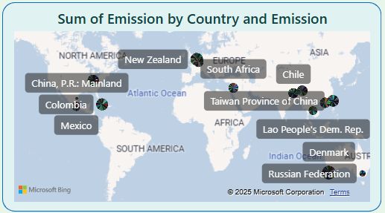

The **map visualization** provides an intuitive view of emission contributions across the globe. Countries such as **China, Mexico, South Africa, and New Zealand** are flagged, illustrating the widespread nature of emissions from this sector. This global footprint emphasizes that emissions reduction is a shared responsibility.

#### **📊 Cumulative Impact**

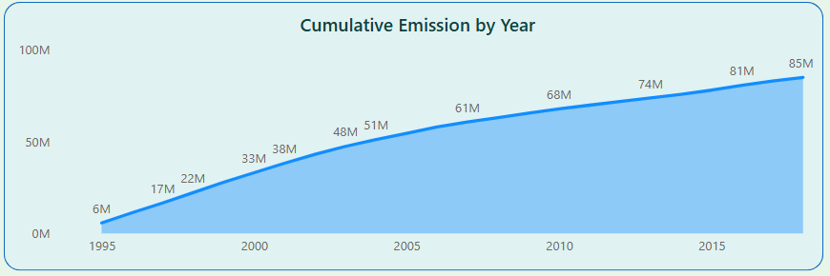

The **Area Chart on cumulative emissions** reinforces the gravity of long-term carbon output. Starting from **6M in 1995**, cumulative emissions climbed steadily to **85M by 2018**. This exponential growth emphasizes that even small annual increases contribute heavily to climate change over time.

### **Conclusion**

This dashboard provides a powerful lens into how the Accommodation and Food Services industry has influenced global CO₂ emissions over two decades. While there are positive signs of declining emissions in recent years, the cumulative totals and persistent high-emission countries reveal that **sustained efforts and global cooperation** are critical.

By leveraging such data-driven insights, stakeholders in both government and industry can make informed decisions to reduce carbon footprints, invest in cleaner technologies, and contribute to a more sustainable future.